Product Design
Team  Members | Team Nova  Kris Sathwara, Sahil Chaudhari, Gauri Kaushik, Brandon Vojtkofsky

Revision Number | Revision Date | Summary of Changes | Author(s)
0.1 | 10/2/2026 | Document created | Team Nova
0.2 | 10/2/2026 | Initial Diagrams added | Kris S.
0.3 | 10/2/2026 | Initial design summary drafted | Brandon V.

Class Diagram(s)
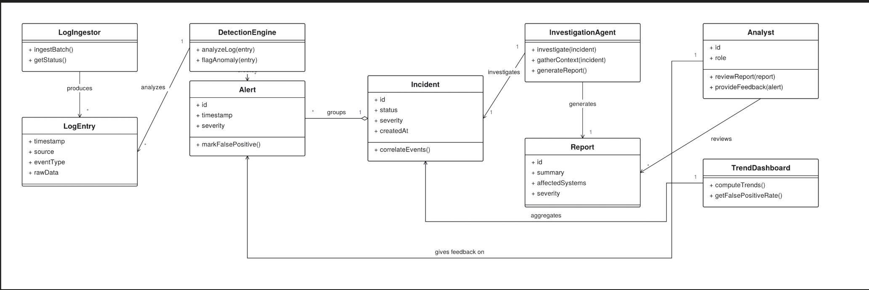

ER Diagram(s)
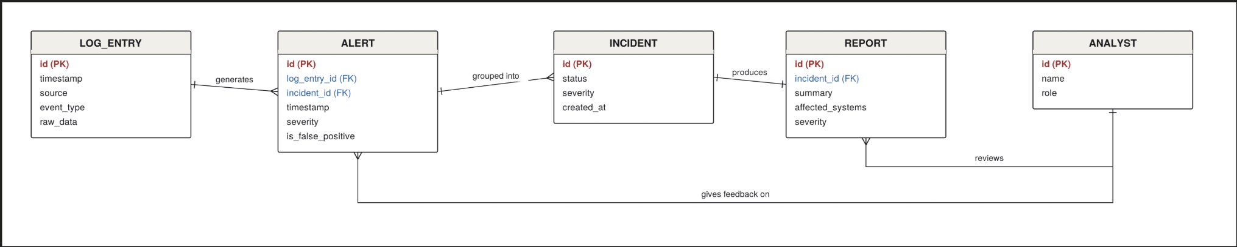

Information Architecture Diagram
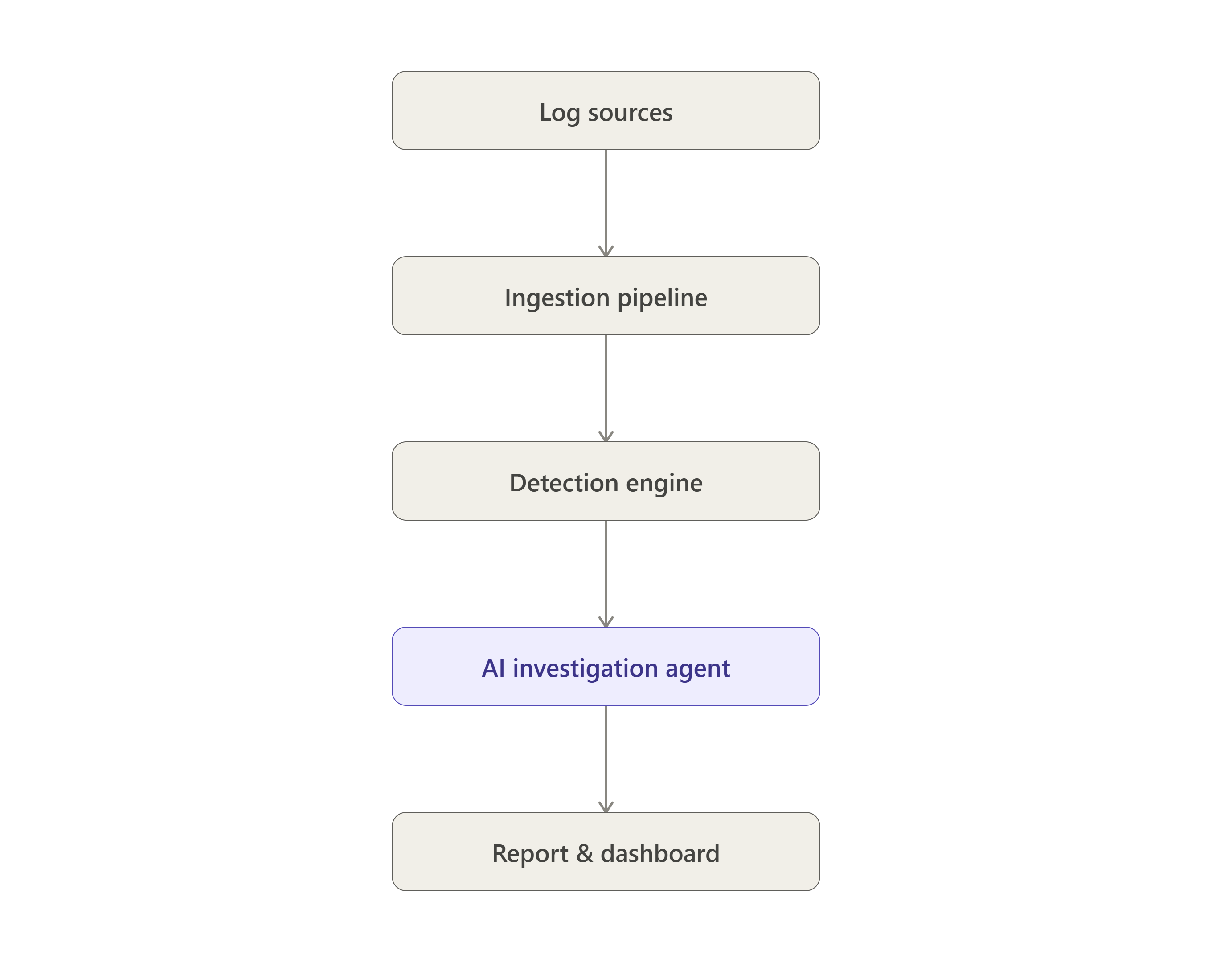
If you are not sure what types of diagram you need for your project, ask right away.

User Interface Wireframe(s)/Screenshot(s)
These are meant to show the appearance and structure of your key screens. If you are developing an app, present these to the scale of the typical phone that you are designing for. Also provide unique screenID’s, captions and annotations that elaborate on your screens.

Design Summary
Our current vision for the project sees a general flow of data fed into the system by the user in the form of log files. Log sources flow down to the ingestion pipeline which produces standardized log entries. These entries are passed to the detection engine which uses them to produce alerts that are then grouped into incidents. each incident is then analyzed by the AI investigation agent which generates a descriptive, concise, easily-readable report that it then presents on the dashboard where the human analyst can provide the system with feedback to improve the quality of reporting.

Design Rationale
This is a running list of issues that arise as your design process proceeds. This is an important section of the design document as it captures the thought process of the product's designers. It includes why or why not (rejected solutions) a design decision was made and supports future changes to the product. It should be updated whenever a design change occurs.

It is RARELY the case that the first design you consider is the best one that you can come up with that meets the requirements and that can be implemented, tested, and delivered on schedule. Your instructor will be looking for signs that you considered at least a few approaches, and that you had a coherent rationale for preferring the design your team eventually adopts.
This is the place to record such thoughts – what alternatives did you consider? What are the strengths (and deficiencies) of the final design compared to the other alternatives considered? Why did you select the approach you finally chose? This last question should be answered with an eye to the tradeoffs inevitably involved in creating an appropriate design.
In addition, if (not when) the design has to be adjusted to meet unexpected problems or new requirements, this is the place to record what changes were made, what effect these had on the work that had been completed to date, and the rationale for the making changes (as opposed to “just toughing it out”).

